

1. Python Program to Solve the 8-Puzzle Problem
AIM
To write a Python program to solve the 8-Puzzle Problem using the Breadth-First Search (BFS) algorithm.
ALGORITHM
- Start with the initial puzzle state.
- Define the goal state.
- Find the empty tile represented by 0.
- Generate possible states by moving the empty tile up, down, left, or right.
- Use a queue to explore the states level by level.
- Stop when the goal state is reached.
- Display the solution path.

PYTHON PROGRAM
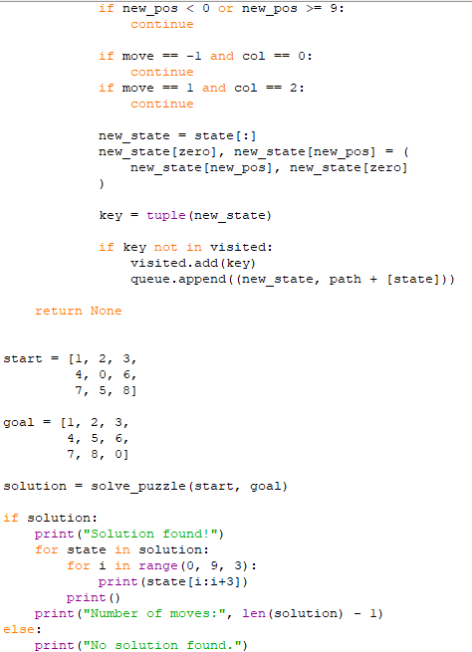

OUTPUT

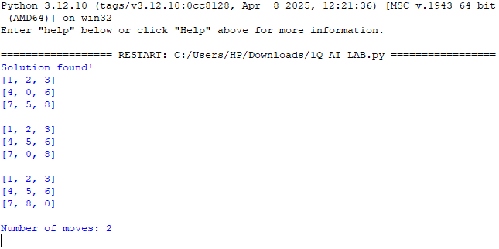
RESULT
Thus, the Python program to solve the 8-Puzzle Problem using the BFS algorithm was executed successfully.
2. Python Program to Solve the 8-Queen Problem
AIM
To write a Python program to solve the 8-Queen Problem using the Backtracking algorithm.
ALGORITHM
- Start placing queens from the first row.
- Place one queen in a column where no other queen attacks it.
- Check whether the column and both diagonals are safe.
- If the position is safe, place the queen and move to the next row.
- If no safe position is available, backtrack and try another column.
- Continue until all 8 queens are placed.
- Display the solution.

OUTPUT
PYTHON PROGRAM
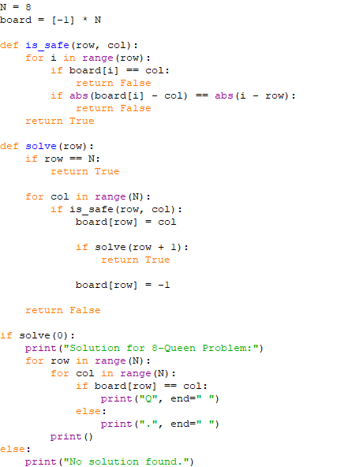
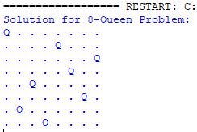

RESULT
Thus, the Python program to solve the 8-Queen Problem using the Backtracking algorithm was executed successfully.

3. Python Program for Water Jug Problem
AIM
To write a Python program to solve the Water Jug Problem using the Breadth-First Search (BFS) algorithm.
ALGORITHM
- Start with both jugs empty.
- Define the capacities of the two jugs and the target quantity.
- Generate possible states by filling, emptying, or pouring water between the jugs.
- Use a queue to explore the states.
- Avoid visiting the same state more than once.
- Stop when the target quantity is reached.
- Display the sequence of states.
PYTHON PROGRAM
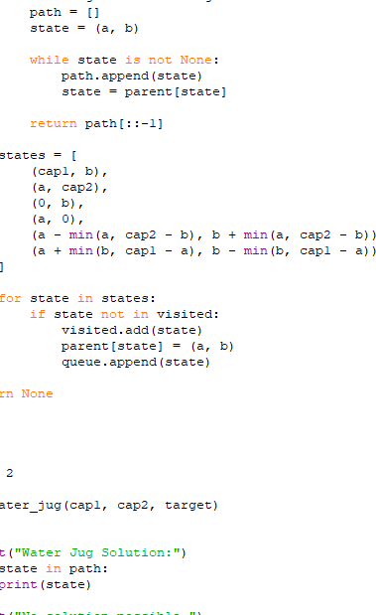
OUTPUT
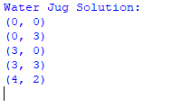

RESULT
Thus, the Python program to solve the Water Jug Problem using the BFS algorithm was executed successfully.

4. Python Program for Crypt-Arithmetic Problem
AIM
To write a Python program to solve a Crypt-Arithmetic Problem in which each letter represents a unique digit.
ALGORITHM
- Start the program.
- Select a crypt-arithmetic puzzle, such as SEND + MORE = MONEY.
- Assign different digits to each letter.
- Ensure that the first letter of each word is not zero.
- Check whether the numerical addition is correct.
- Display the valid digit assignment.
- Stop the program.
PYTHON PROGRAM OUTPUT
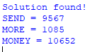
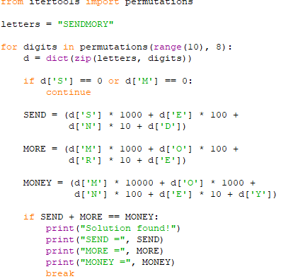

RESULT
Thus, the Python program to solve the Crypt-Arithmetic Problem was executed successfully by assigning unique digits to the letters.

5. Python Program for Missionaries and Cannibals Problem
AIM
To write a Python program to solve the Missionaries and Cannibals Problem using the Breadth-First Search (BFS) algorithm.
ALGORITHM
- Start with three missionaries and three cannibals on the left bank of the river.
- Initialize the boat on the left bank.
- Allow the boat to carry one or two people at a time.
- Ensure that cannibals never outnumber missionaries on either bank when missionaries are present.
- Generate all valid states and avoid revisiting previously visited states.
- Continue until all missionaries and cannibals reach the right bank.
- Display the solution path.
PYTHON PROGRAM OUTPUT
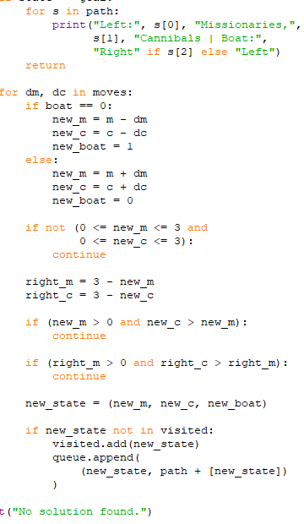
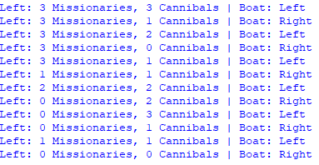
RESULT
Thus, the Python program to solve the Missionaries and Cannibals Problem using the BFS algorithm was implemented successfully.
6. Python Program for Vacuum Cleaner Problem
AIM
To write a Python program to solve the Vacuum Cleaner Problem using an intelligent agent approach.
ALGORITHM
- Start the program.
- Initialize two rooms, A and B, as dirty.
- Place the vacuum cleaner in room A.
- Check whether the current room is dirty.
- If dirty, clean the room.
- Move to the next room and clean it if necessary.
- Display the final status of both rooms.
- Stop the program.
PYTHON PROGRAM OUTPUT
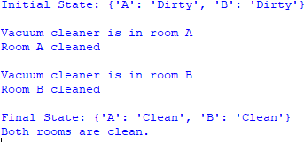
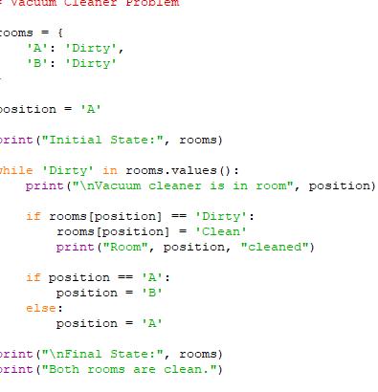
RESULT
Thus, the Python program to solve the Vacuum Cleaner Problem using an intelligent agent approach was executed successfully.

7. Python Program to Implement Breadth-First Search (BFS)
AIM
To write a Python program to implement the Breadth-First Search (BFS) algorithm to traverse a graph.
ALGORITHM
- Start the program.
- Create a graph using an adjacency list.
- Initialize a queue with the starting node.
- Mark the starting node as visited.
- Remove a node from the queue and display it.
- Add its unvisited adjacent nodes to the queue and mark them as visited.
- Repeat until the queue becomes empty.
- Stop the program.
PYTHON PROGRAM OUTPUT
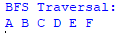
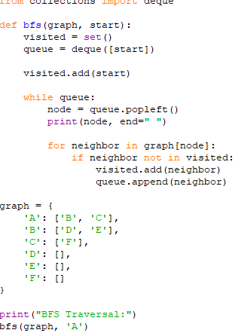
RESULT
Thus, the Python program to implement the Breadth-First Search (BFS) algorithm was executed successfully.
8. Python Program to Implement Depth-First Search (DFS)
AIM
To write a Python program to implement the Depth-First Search (DFS) algorithm to traverse a graph.
ALGORITHM
- Start the program.
- Create a graph using an adjacency list.
- Initialize an empty set to store visited nodes.
- Start the traversal from the given starting node.
- Mark the current node as visited and display it.
- Visit each unvisited adjacent node recursively.
- Continue until all reachable nodes are visited.
- Stop the program.
PYTHON PROGRAM OUTPUT
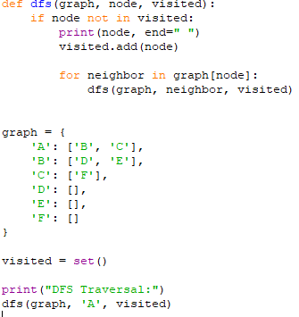
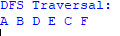

RESULT
Thus, the Python program to implement the Depth-First Search (DFS) algorithm was executed successfully.

9. Python Program to Solve the Travelling Salesman Problem (TSP)
AIM
To write a Python program to solve the Travelling Salesman Problem using the brute-force approach and find the minimum travel cost.
ALGORITHM
- Start the program.
- Define the number of cities and the distance between each pair of cities.
- Fix the first city as the starting point.
- Generate all possible orders of visiting the remaining cities.
- Calculate the total travel cost for each route, including the return to the starting city.
- Select the route with the minimum travel cost.
- Display the optimal route and its minimum cost.
- Stop the program.
PYTHON PROGRAM OUTPUT
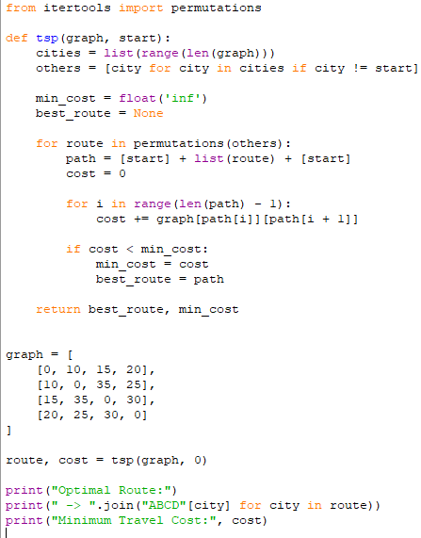
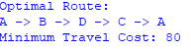
RESULT
Thus, the Python program to solve the Travelling Salesman Problem using the brute-force approach was executed successfully, and the minimum travel cost was found to be 80.
10. Python Program to Implement the A* Algorithm
AIM
To write a Python program to implement the A* search algorithm to find the shortest path between a starting node and a goal node using the cost function and heuristic function.
ALGORITHM
- Start the program.
- Define the graph with edge costs and heuristic values for each node.
- Initialize the starting node with a cost of zero.
- Calculate the evaluation function using f(n) = g(n) + h(n), where g(n) is the actual cost and h(n) is the estimated cost to the goal.
- Select the node with the lowest evaluation value.
- Explore its neighbouring nodes and update their costs.
- Continue until the goal node is reached.
- Display the shortest path and its total cost.
- Stop the program.
PYTHON PROGRAM OUTPUT
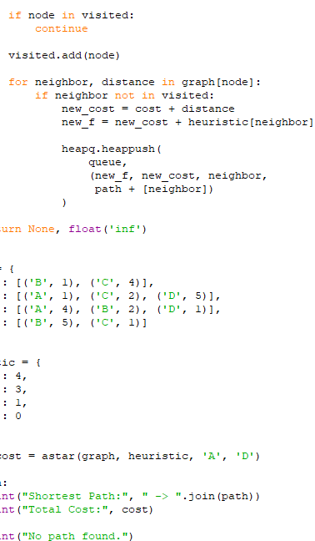
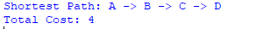
RESULT
Thus, the Python program to implement the A* search algorithm was executed successfully, and the shortest path from the starting node to the goal node was found with a total cost of 4.
11: MAP COLORING USING CSP
AIM
To write a Python program to solve the Map Coloring Problem using a Constraint Satisfaction Problem (CSP).
ALGORITHM
- Define the map regions and their neighboring regions.
- Define the available colors.
- Assign a color to each region.
- Check whether neighboring regions have different colors.
- If a conflict occurs, select another color.
- Continue until all regions are colored.
- Display the solution.
PYTHON PROGRAM OUTPUT
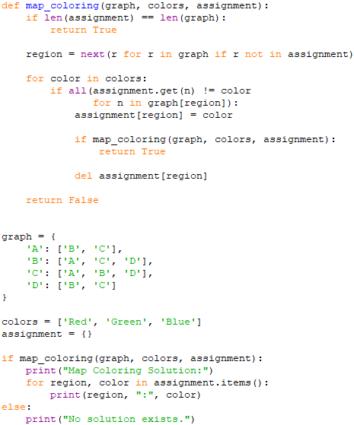
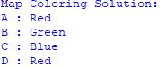

RESULT
Thus, the Python program to solve the Map Coloring Problem using CSP was executed successfully.
12: TIC TAC TOE GAME
AIM
To write a Python program to implement the Tic Tac Toe game between two players.
ALGORITHM
- Create a 3 × 3 board.
- Display the board.
- Ask the current player to enter a position.
- Check whether the position is empty.
- Place the player's symbol in the selected position.
- Check for a winning combination or a draw.
- Switch players if the game continues.
- Display the final result.
PYTHON PROGRAM OUTPUT
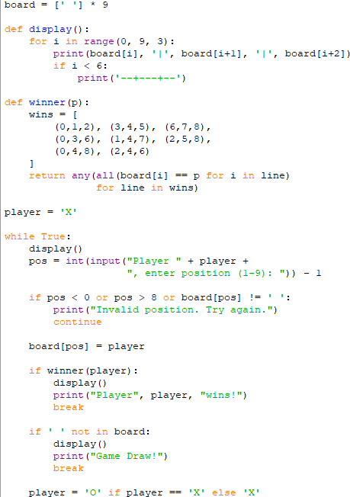
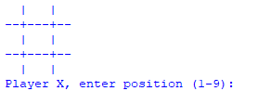

RESULT
Thus, the Python program to implement the Tic Tac Toe game between two players was executed successfully.
13: MINIMAX ALGORITHM FOR GAMING
AIM
To write a Python program to implement the Minimax algorithm for selecting the best move in a two-player game.
ALGORITHM
- Define the game tree with terminal values.
- Identify the maximizing and minimizing levels.
- At the maximizing level, select the maximum value.
- At the minimizing level, select the minimum value.
- Continue until the root node is evaluated.
- Display the best value.
PYTHON PROGRAM OUTPUT
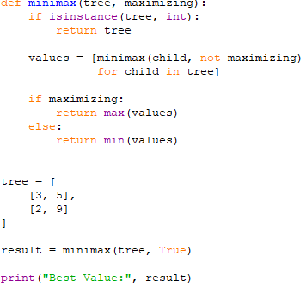

RESULT
Thus, the Python program to implement the Minimax algorithm for gaming was executed successfully.

14: ALPHA-BETA PRUNING ALGORITHM
AIM
To write a Python program to implement the Alpha-Beta Pruning algorithm to optimize the Minimax search in a two-player game.
ALGORITHM
- Initialize alpha to negative infinity and beta to positive infinity.
- Evaluate the game tree recursively.
- At the maximizing level, update alpha with the maximum value.
- At the minimizing level, update beta with the minimum value.
- Stop exploring a branch when alpha is greater than or equal to beta.
- Return the best value.
PYTHON PROGRAM OUTPUT
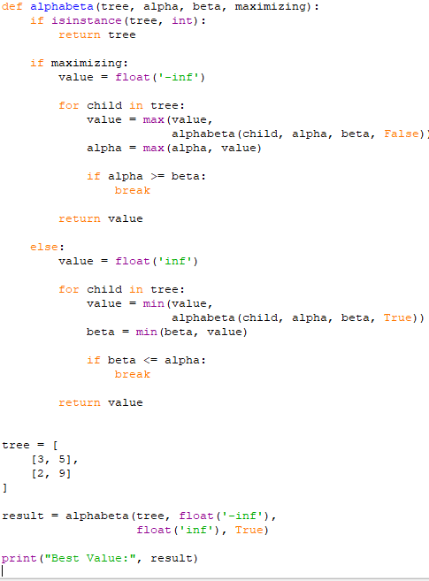
RESULT
Thus, the Python program to implement the Alpha-Beta Pruning algorithm was executed successfully.

15: DECISION TREE
AIM
To write a Python program to implement a Decision Tree classifier and predict the class of a given input.
ALGORITHM
- Import the Decision Tree classifier from the Scikit-learn library.
- Prepare the training dataset and corresponding class labels.
- Create a Decision Tree classifier.
- Train the model using the dataset.
- Provide a new input for prediction.
- Predict and display the output class.
PYTHON PROGRAM OUTPUT
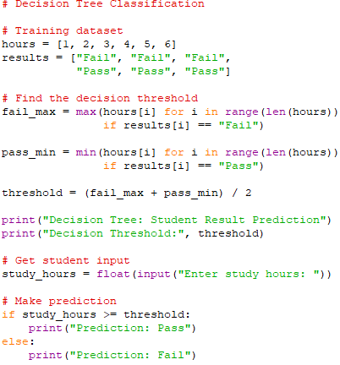
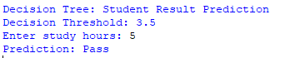
RESULT
Thus, the Python program to predict a student's result using a simple decision-tree-style classifier was executed successfully.

